Quarterly Dataset

**Fund Profile:**

* Fund_profile
* Fund_profile_merged
* Fund_profile_non_merged

|  |  |  |
| --- | --- | --- |
| **Variable Name** | **Description** | **Notes** |
| **Period** | Period of Observation |  |
| **MySuper Product Name** | Name of MySuper product |  |
| **MySuper Product Type** | Classification of MySuper product | Either generic, goodwill or large employer |
| **Fund Name** | Name of fund company |  |
| **Fund ABN** | ABN of company |  |
| **Merger** | Dummy variable to determine if fund is acquirer | Only in merged dataframes |
| **Merged** | Dummy variable to determine if fund is target | Only in merged dataframes |
| **Acquirer** | To determine acquiring fund in merger | Only in merged dataframes |
| **ret target** | Return target (annualised target net return above CPI over ten years) | Expressed as % |
| **tot inv** | Total Investments | ($ million) |
| **cash** | Cash – Benchmark Asset Allocation | % |
| **Fixedinc** | Fixed income – Benchmark Asset Allocation | % |
| **auseq** | Australian listed equity – Benchmark Asset Allocation | % |
| **Inteq** | International listed equity – Benchmark Asset Allocation | % |
| **unlieq** | Unlisted equity – Benchmark Asset Allocation | % |
| **unspeq** | Equity (listing and/or domicile not specified) – Benchmark Asset Allocation | % |
| **prop** | Property – Benchmark Asset Allocation | % |
| **infra** | Infrastructure – Benchmark Asset Allocation | % |
| **comm** | Commodities – Benchmark Asset Allocation | % |
| **other** | Other investments – Benchmark Asset Allocation | % |

**Investment Performance**

* Investment_performance
* Investment_performance_merged
* Investment_non_merged

|  |  |  |
| --- | --- | --- |
| **Variable Name** | **Description** | **Notes** |
| **Period** | Period of Observation |  |
| **MySuper Product Name** | Name of MySuper product |  |
| **MySuper Product Type** | Classification of MySuper product | Either generic, goodwill or large employer |
| **Fund Name** | Name of fund company |  |
| **Fund ABN** | ABN of company |  |
| **Merger** | Dummy variable to determine if fund is acquirer | Only in merged dataframes |
| **Merged** | Dummy variable to determine if fund is target | Only in merged dataframes |
| **Acquirer** | To determine acquiring fund in merger | Only in merged dataframes |
| **invfeem** | Investment fees (rep member) | % |
| **invcostm** | Investment costs – other (rep member) | % |
| **totinvm** | Total investment fees and costs (rep member) | % |
| **netret** | Net Investment Return | % |
| **admfeem** | Admin fees (rep member) | % |
| **admcostm** | Admin costs – other (rep member) | % |
| **totadmm** | Total administration fees and costs (rep member) | % |
| **advfeem** | Advice fees (rep member) | % |
| **advcostm** | Advice costs – other (rep member) | % |
| **totadvm** | Advice fees and costs (rep member) | % |
| **quartnret** | Net return (rep member) – Quarterly | % |
| **onenret** | One-year net return (rep member) – Annualised | % |
| **threenret** | Three-year net return (rep member) – Annualised | % |
| **fivenret** | Five-year net return (rep member) – Annualised | % |
| **totalfc** | Total fees and costs (rep member) | % |

**MySuper Fees**

* Mysuper_fees
* Mysuper_fees_merged
* Mysuper_fees_merged

|  |  |  |
| --- | --- | --- |
| **Variable Name** | **Description** | **Notes** |
| **Period** | Period of Observation |  |
| **MySuper Product Name** | Name of MySuper product |  |
| **MySuper Product Type** | Classification of MySuper product | Either generic, goodwill or large employer |
| **Fund Name** | Name of fund company |  |
| **Fund ABN** | ABN of company |  |
| **Merger** | Dummy variable to determine if fund is acquirer | Only in merged dataframes |
| **Merged** | Dummy variable to determine if fund is target | Only in merged dataframes |
| **Acquirer** | To determine acquiring fund in merger | Only in merged dataframes |
| **IndCost** | Indirect Cost Ratio | % |
| **InvFee** | Investment fees (rep member) | % |
| **AdmFee** | Administration fees (rep member) | % |
| **AdvFee** | Advice fees (rep member) | % |
| **InsFee** | Insurance fees (rep member) | % |
| **OthFee** | Other fees (% of member balance | % |

**Admin Fees**

* Admin_fees
* Admin_fees_merged
* Admin_fees_non_merged

|  |  |  |
| --- | --- | --- |
| **Variable Name** | **Description** | **Notes** |
| **Period** | Period of Observation |  |
| **MySuper Product Name** | Name of MySuper product |  |
| **MySuper Product Type** | Classification of MySuper product | Either generic, goodwill or large employer |
| **Fund Name** | Name of fund company |  |
| **Fund ABN** | ABN of company |  |
| **Merger** | Dummy variable to determine if fund is acquirer | Only in merged dataframes |
| **Merged** | Dummy variable to determine if fund is target | Only in merged dataframes |
| **Acquirer** | To determine acquiring fund in merger | Only in merged dataframes |
| **adminfee** | Administration fee level –(% of member balance) | % |

**Activity Fees**

* Activity_fees
* Activity_fees_merged
* Activity_fees_non_merged

|  |  |  |
| --- | --- | --- |
| **Variable Name** | **Description** | **Notes** |
| **Period** | Period of Observation |  |
| **MySuper Product Name** | Name of MySuper product |  |
| **MySuper Product Type** | Classification of MySuper product | Either generic, goodwill or large employer |
| **Fund Name** | Name of fund company |  |
| **Fund ABN** | ABN of company |  |
| **Merger** | Dummy variable to determine if fund is acquirer | Only in merged dataframes |
| **Merged** | Dummy variable to determine if fund is target | Only in merged dataframes |
| **Acquirer** | To determine acquiring fund in merger | Only in merged dataframes |
| **Activity** | Activity fee | $ |

Annual Dataset

**Fees:**

* Fees
* Fees_merged
* Fees_non_merged

|  |  |  |
| --- | --- | --- |
| **Variable Name** | **Description** | **Notes** |
| **Period** | Period of Observation |  |
| **Fund Name** | Name of fund company |  |
| **ABN** | ABN of company |  |
| **Merger** | Dummy variable to determine if fund is acquirer | Only in merged dataframes |
| **Merged** | Dummy variable to determine if fund is target | Only in merged dataframes |
| **Acquirer** | To determine acquiring fund in merger | Only in merged dataframes |
| **Fund type** | Fund category | Retail, Corporate, Industry, Public Sector |
| **TtlAcc** | Total number of member accounts |  |
| **TtlFees** | Total fees paid | Expressed as ($’000) |
| **InvFees** | Total Investment fees paid | Expressed as ($’000) |
| **InvFprp** | Investment fees paid as a proportion of total fees paid | % |
| **AdmFees** | Total administration fees paid | Expressed as ($’000) |
| **AdmFprp** | Administration fees paid as a proportion of total fees paid | % |
| **AdvFees** | Total advice fees paid | Expressed as ($’000) |
| **AdvFprp** | Advice fees paid as a proportion of total fees paid | % |
| **InsFees** | Total Insurance fees paid | Expressed as ($’000) |
| **InsFprp** | Insurance fees paid as a proportion of ttal fees paid | % |
| **ExtFees** | Total exit fees paid | Expressed as ($’000) |
| **ExtFprp** | Exit fees paid as a proportion of total fees paid | % |
| **SwtFees** | Total switching fees paid | Expressed as ($’000) |
| **SwtFPrp** | Switching fees paid as a proportion of total fees paid | % |
| **OthFees** | Total other fees paid | Expressed as ($’000) |
| **OthFPrp** | Other fees paid as a proportion of total fees paid | % |
| **ActFees** | Total activity fees paid | Expressed as ($’000) |
| **ActFPrp** | Activity fees paid as a proportion of total fees paid | % |

**Performance:**

* Financial_performance
* Financial_merged
* Financial_non_merged

|  |  |  |
| --- | --- | --- |
| **Variable Name** | **Description** | **Notes** |
| **Period** | Period of Observation |  |
| **Fund Name** | Name of fund company |  |
| **ABN** | ABN of company |  |
| **Merger** | Dummy variable to determine if fund is acquirer | Only in merged dataframes |
| **Merged** | Dummy variable to determine if fund is target | Only in merged dataframes |
| **Acquirer** | To determine acquiring fund in merger | Only in merged dataframes |
| **Fund type** | Fund category | Retail, Corporate, Industry, Public Sector |
| **NtABeg** | Net assets at beginning of period | Expressed as ($’000) |
| **TtlIn** | Total Member’s benefits flows in | Expressed as ($’000) |
| **TtlOut** | Total Member’s benefits flow out | Expressed as ($’000) |
| **NtFlows** | Net member’s benefit flows | Expressed as ($’000) |
| **NtOuRt** | Net member’s benefits outflow ratio | % |
| **TtlGain** | Total gains/losses | Expressed as ($’000) |
| **InvInc** | Investment income and gains/losses | Expressed as ($’000) |
| **NtEarn** | Net earnings | Expressed as ($’000) |
| **NtEaTx** | Nt earnings after tax | Expressed as ($’000) |
| **NtAEnd** | Net assets at the end of period | Expressed as ($’000) |
| **1YrRet** | One-year rate of return | % |

**Fund Profile**

* Fund_profile
* Fund_profile_merged
* Fund_profile_non_merged

|  |  |  |
| --- | --- | --- |
| **Variable Name** | **Description** | **Notes** |
| **Period** | Period of Observation |  |
| **Fund Name** | Name of fund company |  |
| **ABN** | ABN of company |  |
| **Merger** | Dummy variable to determine if fund is acquirer | Only in merged dataframes |
| **Merged** | Dummy variable to determine if fund is target | Only in merged dataframes |
| **Acquirer** | To determine acquiring fund in merger | Only in merged dataframes |
| **Fund type** | Fund category | Retail, Corporate, Industry, Public Sector |
| **TtlAst** | Total Assets | Expressed as ($’000) |
| **PrcAst** | Proportion of total assets in default or MySuper strategy | % |
| **InvExpR** | Investment expenses ratio | % |
| **OprExpR** | Operating expense ratio | % |
| **1YrRet** | One-year rate of return | % |
| **5YrRet** | Five-year rate of return | % |
| **10YrRet** | Ten-year rate of return | % |
| **TtlAcc** | Total number of member accounts |  |
| **GrwAcc** | Growth in member accounts | % |

**Summary Statistics – Quarterly**

**Fund Profile Dataset:**

**Fund Profile Merged Dataset:**

**Fund Profile Non-merged Dataset:**

**Investment Performance Dataset:**

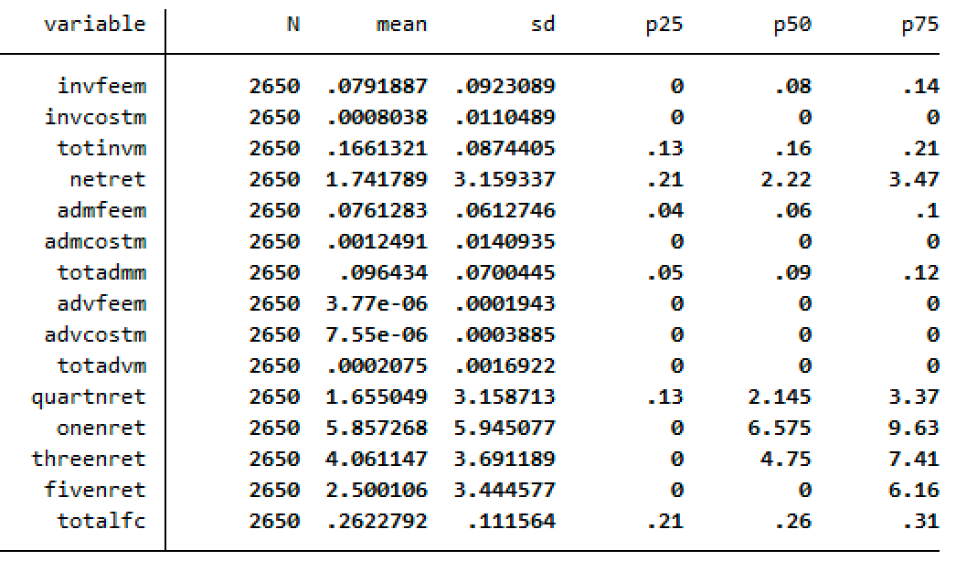

**Investment Performance Merged Dataset:**

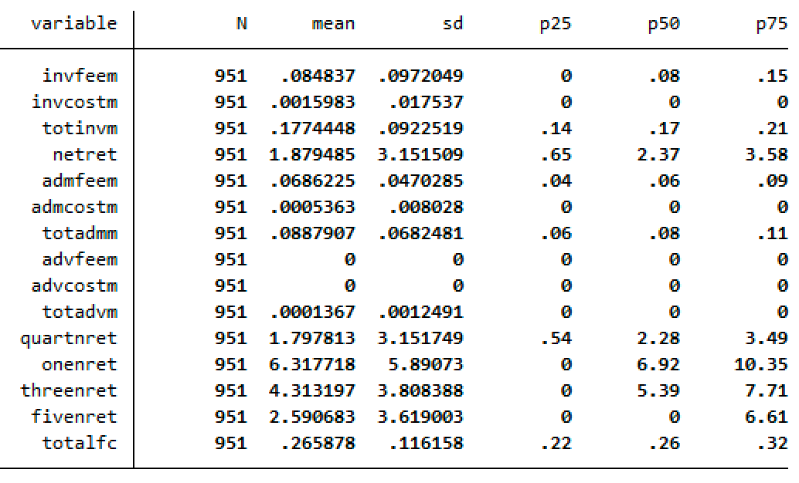

**Investment Performance Non Merged Dataset:**

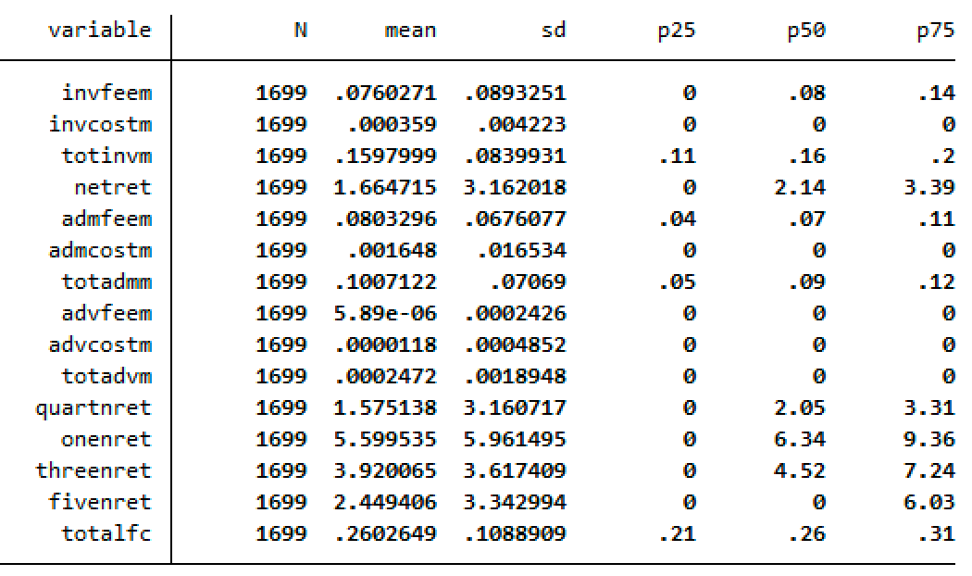

**MySuper Fees Dataset:**

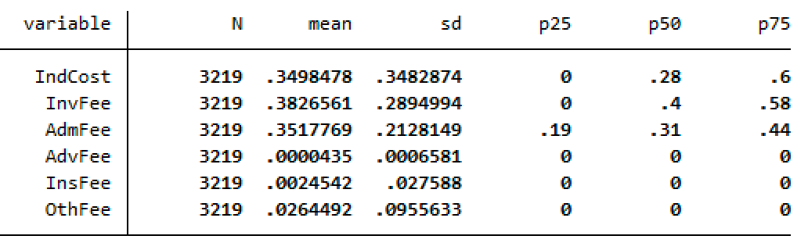

**MySuper Fees Merged Dataset:**

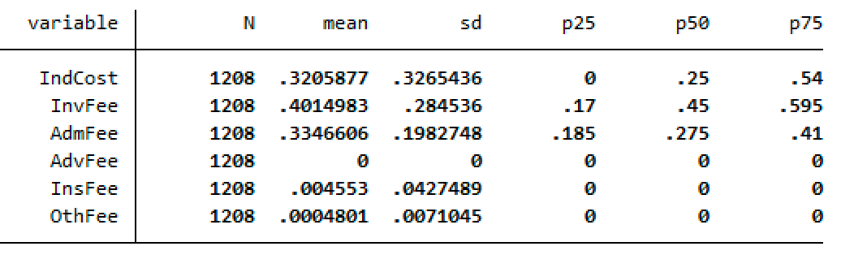

**MySuper Fees Non-merged Dataset:**

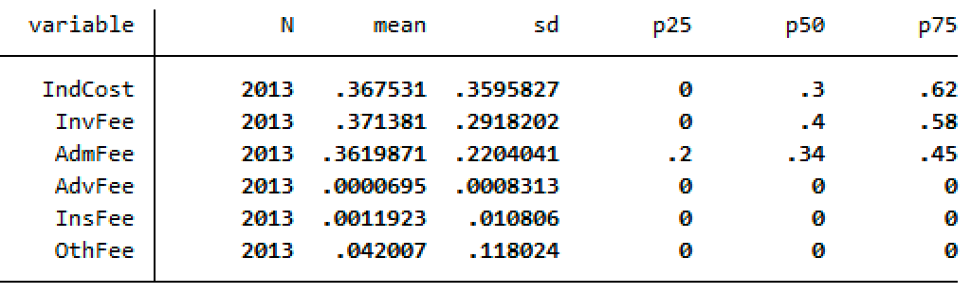

**Admin Fees Dataset:**

**Admin Fee Merged Dataset:**

**Admin Fee Non Merged Dataset:**

**Activity Fees Dataset:**

**Activity Fees Merged Dataset:**

**Activity Fees Non-merged Dataset**

**Summary Statistics – Annual**

**Fees Dataset:**

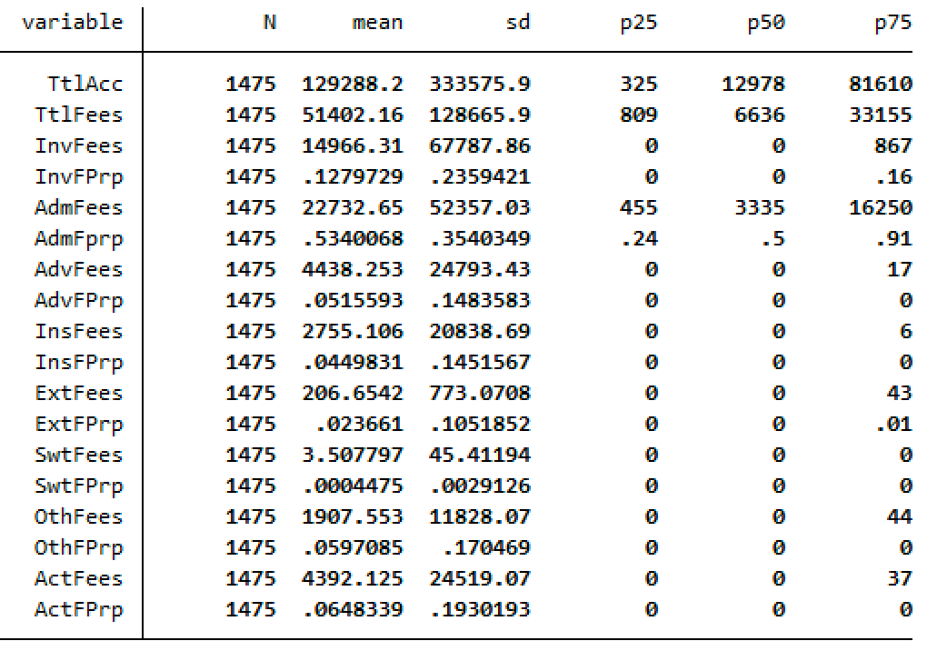

**Fees Merged Dataset:**

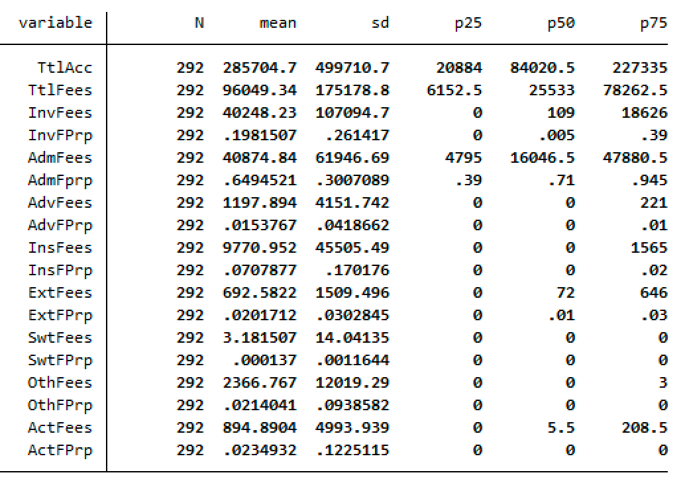

**Fees Non-merged Dataset:**

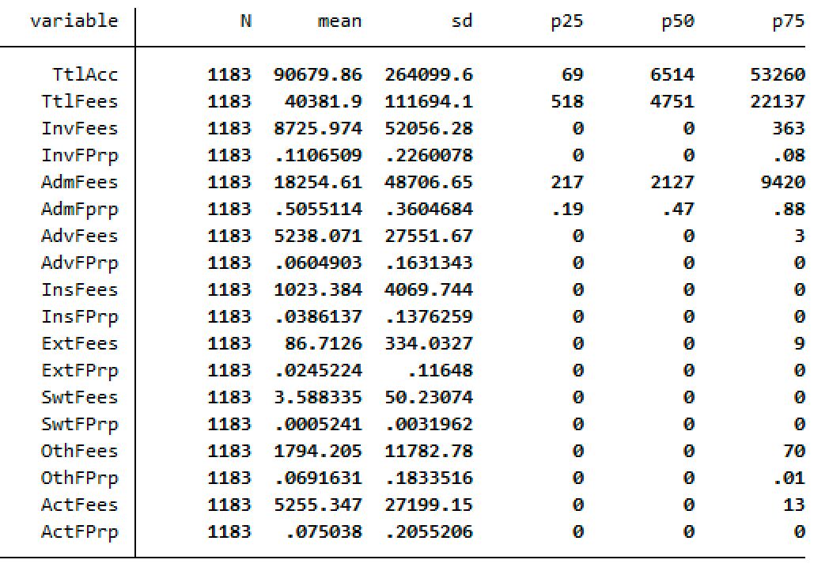

**Performance Dataset:**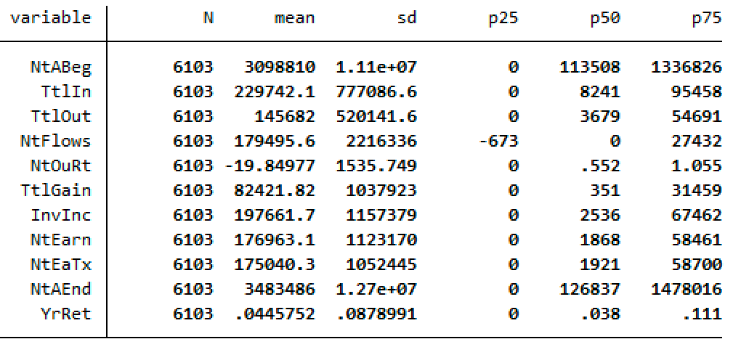

**Performance Merged Dataset:**

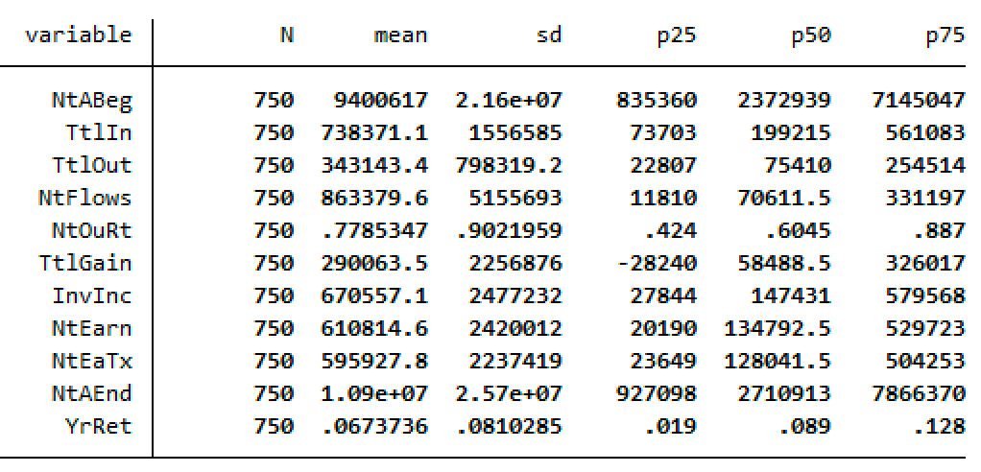

**Performance Non-merged Dataset:**

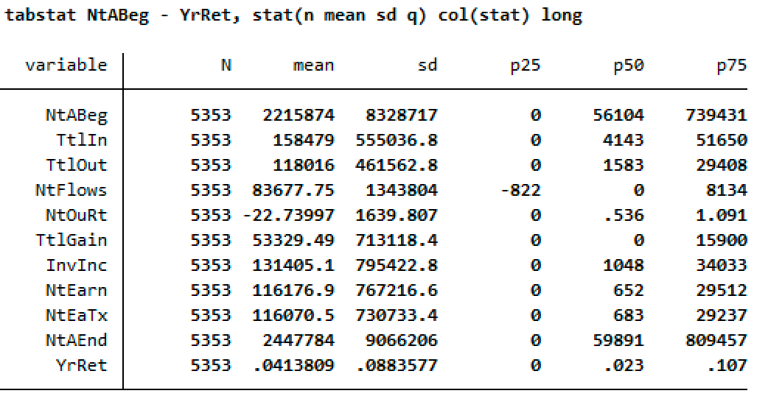

**Fund Profile Dataset:**

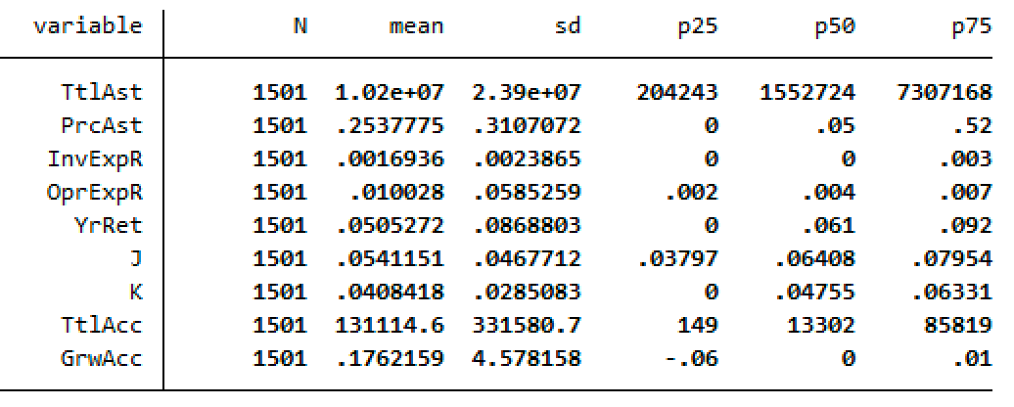

**Fund Profile Merged Dataset:**

**Fund Profile Non-merged Dataset:**

Note: YrRet = 1YrRet, J(M) = 5YrRet, K(N) = 10YrRet